**SQL Hackathon January 2024 Extra Queries**

**Team Number: Team1**

**Team Name: Schema Squad**

**Team Members:**

**Total Extra Questions: 7**

**Question 1:**

Display the arrays of the patients, total number of patients for all combinations of hypertension and diabetes comorbidities with having at least one of the two.

**Description:**

Functions used: array_length, array_agg

**Query:**

SELECT comorbidity AS comorbidity

,array_length(ARRAY_AGG(patient),1)as noOFPatients

,ARRAY_AGG(patient)as array_OF_Patients

FROM(

SELECT patient_id AS patient

,CASE

WHEN com_hypertension=1 AND com_diabetes=1 THEN 'Hypertension-Diabetes'

WHEN com_diabetes=1 AND com_hypertension=0 THEN 'Diabetes-noHypertension'

WHEN com_diabetes=0 AND com_hypertension=1 THEN 'NoDiabetes-Hypertension'

END AS comorbidity

FROM comorbidities

WHERE com_hypertension=1

OR com_diabetes=1

) data(patient,comorbidity) GROUP BY comorbidity

**Result:**

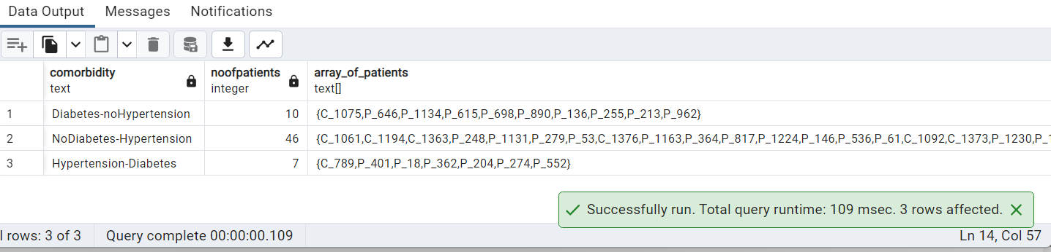

**Question 2:**

Display all comorbidities having less than 15 patients using unnest function from the result of above question Question 1

**Description:**

Functions used: UNNEST

**Query:**

SELECT UNNEST(d.array_OF_Patients) AS patient_id,d.comorbidity

FROM

(

SELECT comorbidity AS comorbidity

,array_length(ARRAY_AGG(patient),1)as noOFPatients

,ARRAY_AGG(patient)as array_OF_Patients

FROM

(

SELECT concat(patient_id, '') as patient,

CASE

WHEN com_hypertension=1 AND com_diabetes=1 THEN 'Hypertension-Diabetes'

WHEN com_diabetes=1 AND com_hypertension=0 THEN 'Diabetes-noHypertension'

WHEN com_diabetes=0 AND com_hypertension=1 THEN 'NoDiabetes-Hypertension'

END AS comorbidity

FROM comorbidities

WHERE com_hypertension=1

OR com_diabetes=1

) AS data(patient,comorbidity)

GROUP BY comorbidity

)d

WHERE d.noOfpatients<15

ORDER BY d.noOfpatients

**Result:**

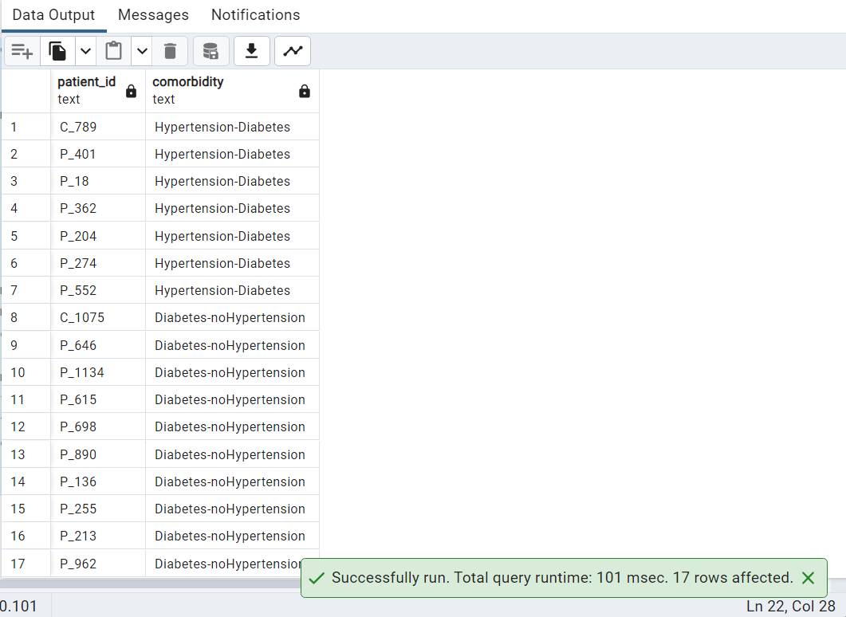

**Question 3:**

Find the list of prescribed drug starting with vowels and ends with alphabet 'b' using REGEXP_LIKE

**Description:**

Functions used: REGEXP_LIKE

**Query:**

SELECT

DISTINCT(prescribed_drug) AS drug_name_startswith_vowel_endswith_b

FROM

Patient_msdetails

WHERE REGEXP_LIKE(prescribed_drug,'^[aeiou][\w]*[b]$','i')

ORDER BY prescribed_drug;

**Result:**

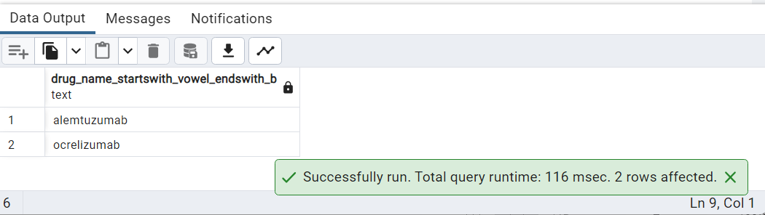

**Question 4:**

Display all the patients self isolated in the last quarter of every year present in dataset along with year and quarter. (4th quarter— from October-December)

**Description:**

Functions used: EXTRACT QUARTER

**Query:**

SELECT

COUNT(patient_id),

to_char(date_trunc('quarter', date_of_onset)::date, 'yyyy-q')

FROM

covid_details

WHERE EXTRACT(QUARTER FROM date_of_onset)=4

AND covid19_self_isolation=1

GROUP BY to_char(date_trunc('quarter', date_of_onset)::date, 'yyyy-q')

ORDER BY to_char(date_trunc('quarter', date_of_onset)::date, 'yyyy-q');

**Result:**

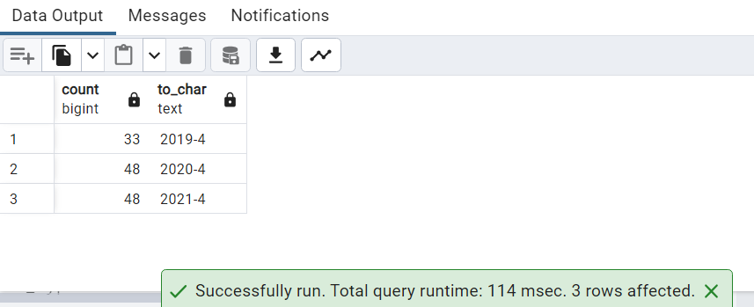

**Question 5:**

Display the string of all female pregnant patients,report source in age cat 1 for all ms_type2

**Description:**

Functions used: STRING_AGG

**Query:**

SELECT

ms_type2, string_agg(patient_id,',') AS patients

,STRING_AGG(report_source,',') AS report_source

FROM patient_details

WHERE age_in_cat =1

AND sex='female'

AND pregnancy=1

GROUP BY ms_type2

ORDER BY ms_type2;

**Result:**

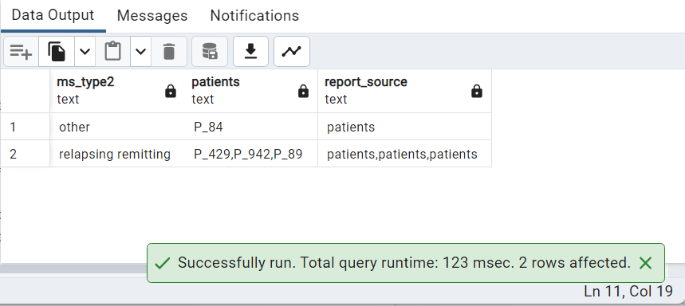

**Question 6:**

Write a query displays count of hospitalized patients along with count of patient those are admitted in icu or in self isolation

**Description:**

Functions used: FILTER

**Query:**

SELECT

COUNT(patient_id),

COUNT(patient_id) FILTER(WHERE covid19_self_isolation=1) iso_count,

COUNT(patient_id) FILTER(WHERE covid19_icu_stay=1) icu_count

FROM covid_details

WHERE covid19_admission_hospital=1

AND (covid19_self_isolation=1

OR covid19_icu_stay =1);

**Result:**

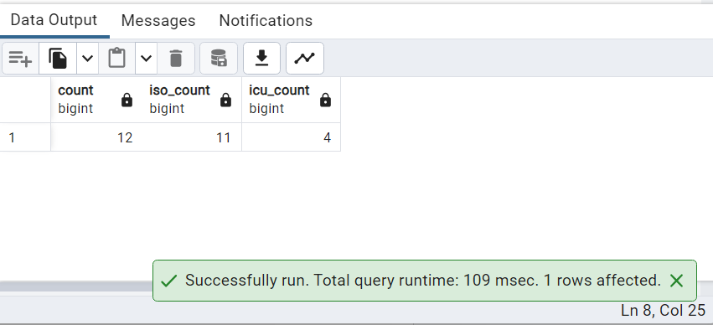

**Question 7:**

Create a table with JSON data Type. Insert data from patient_details. Display all female patients data

**Description:**

Functions used: jsonb_build_object

**Query:**

CREATE TABLE

covid_patient_json_tbl

(

id serial NOT NULL PRIMARY KEY,

info json NOT NULL

);

INSERT INTO

covid_patient_json_tbl(info)

SELECT

row_to_json(x)::jsonb FROM

(

SELECT jsonb_build_object('patient_id', patient_id) AS patient,

jsonb_build_object('sex', sex, 'age_in_cat', age_in_cat) AS patient_det

FROM patient_details

) x;

--DISPLAY ALL PATIENTS DATA

SELECT info

FROM

covid_patient_json_tbl;

--DISPLAYS ALL FEMALE PATIENTS DATA

SELECT info->>'patient' AS patient,

info->>'patient_det' AS age_type

FROM

covid_patient_json_tbl

WHERE info ->'patient_det'->>'sex' ='female'

**Result:**

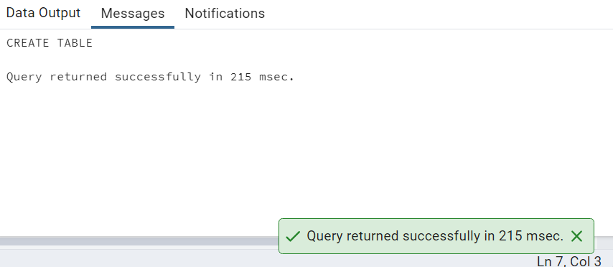

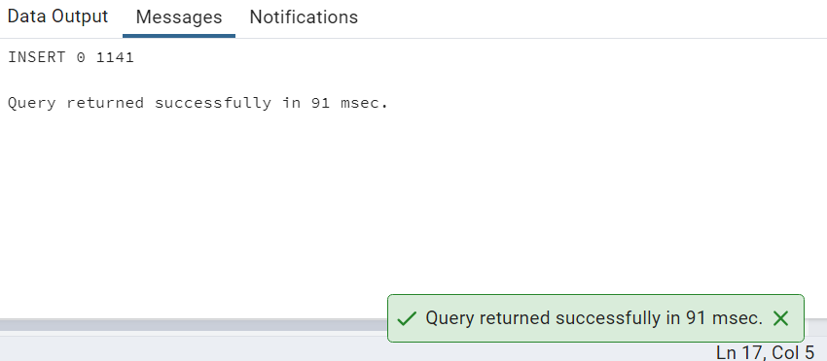

**LIST OF ALL PATIENTS**

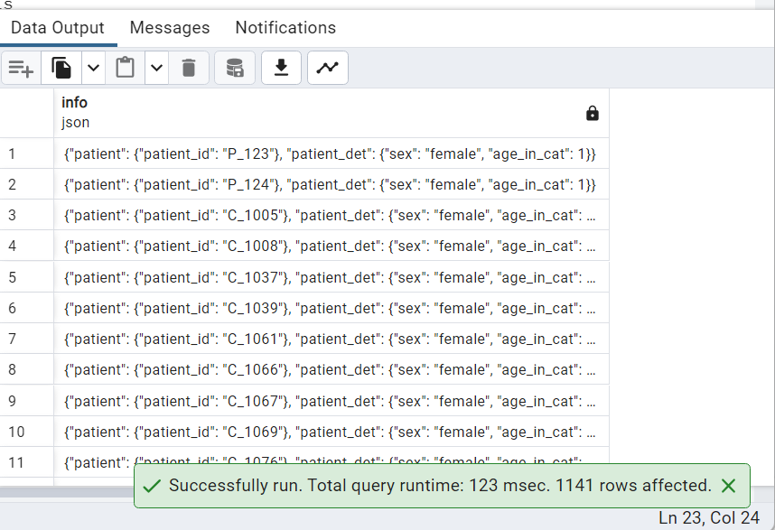

**LIST OF ALL FEMALE PATIENTS**

